Maintenance Monitoring Sheet
- ANIMAL DETAILS
AEC Project # |  | Monitoring frequency | Daily
Name of CI and  researchers |  | Strain
Room number |  | Number of Cages in Room

- MONITORING
Date
Time
Number of cages
Criteria
Behavioural abnormality
Physical abnormality
Cage environment abnormality
Total
Signature
OFFICE USE ONLY
AWO CHECK

Scoring criteria:
- Yes = 1 - Behavioural abnormality – no activity, abnormal activity, poor nest formation, abnormal gait, hunching, facial grimace
  - Action required – commence twice daily monitoring with post-procedure clinical record sheet
- No = 0 – Behavioural normal – bright and alert, active, resting/sleeping in nest, normal gait, absence of hunching/facial grimace
- Yes = 1 – Physical abnormality – presence of lesions, asymmetry, swellings, low body condition score (less than 2 out of 5- see next page for description)
- No = 0 – Physically normal
- Yes = 1 – Cage/environment abnormality – air flow, temperature, humidity, contamination, moisture, ammonia
- No = 0 – Cage/environment normal - air flow, temperature, humidity, contamination, moisture, ammonia

If a score of 1 is recorded for any of the criteria, twice daily monitoring with post-procedure Clinical Record Sheet will commence.

Cages identified for twice daily monitoring (indicate method of cage identification)

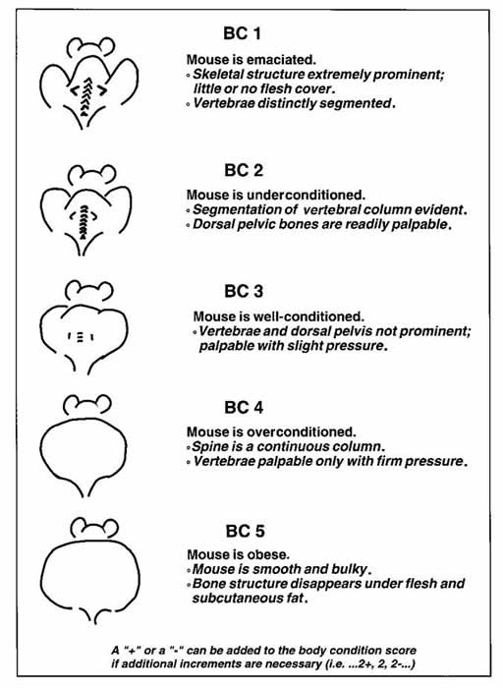
Fig. 3.2 Schematic for scoring of the mouse body condition (from Hankenson CF 2014, Critical Care Management for Laboratory Mice and Rats, CRC Press, Florida.)

