Individual Clinical Record Coversheet

Project Number
Project Title
Chief Investigator
Monitoring Start Date /
Animal Issue Date

- CONTACT DETAILS

Contact Type | Name | Contact Number
Emergency Contact
Researcher (1)
Researcher (2)
Researcher (3)
Animal Facility Staff
Animal Welfare Officer | Lewis Vaughan | 0450 424 143
Other (please specify)

- SPECIES / PHENOTYPE / MODEL ISSUES

- MONITORING CRITERIA

CRS Column # | Clinical Criteria | No obvious deviation from normal | Slight or moderate deviation from normal | Significant or sustained deviation from normal
 | Score | 0 | 1 | 2
1 | Lack of, or abnormal movement | Active spontaneous free movement | Lack of spontaneous movement/hyperactivity/occasional ataxia /circling/dragging legs | Reduced movement on stimulation/frequent ataxia, circling, locomotion defects
2 | Posture | Extended back, normal movement and gait | Slight arching on movement | Arched on movement
3 | Ruffled coat | Smooth sleek coat | Slight ruffling | Significant ruffling over entire coat
4 | Abnormal breathing | Normal breathing in character and frequency | Increased respiratory rate or slight increased effort | Marked increase in respiratory rate with marked effort
5 | Skin crinkling/tenting/sunken eyes | Soft, pliable, elastic, bright eyes (> 75% open) | Skin crinkled, slight tenting when skin lifted | Skin tenting and sunken eyes
6 | Injury | No incision anomaly or evidence of injury | -  (Not scored – all significant injuries are to be reported to the AWO) | Significant injury/body cavity penetration/ skin excoriation ≥ 1 cm²/scratching/obvious swelling/ discharge/gaping wound
Optional additional criteria are shown below – These should be included if applicable to the project, or interchanged with project specific criteria. Example: tumour-scoring criteria for tumour studies.
7 | Abnormal discharge from orifices | No discharges | Slight discharge (blood/pus etc) from any orifice | Significant discharge (blood/pus etc) from any orifice -
8 | Profuse/bloody diarrhoea | Well-formed stools | Profuse with cage smeared with diarrhoea | Bloody & profuse diarrhoea
Note: Training by the AWO or pictures or video footage of the monitoring criteria at the various scoring points is recommended to ensure all personnel are consistent in terms of scoring.

- MONITORING AND WEIGHING FREQUENCY

Describe monitoring regime.

- ACTIONS AND INTERVENTIONS

Total Score | Animal Assessment | Actions/Interventions
0 | Within normal limits | No interventions required.
1 | Slight or moderate deviation from normal | Provide analgesia if indicated, consult AWO if in doubt. Daily monitoring required
2 | Moderate abnormality | - Score 2 for any one criterion – consult AWO.  - Cumulated score 2 – increase monitoring to twice daily.
3 | Moderate/sustained abnormality in more than one criterion | Consult AWO, follow advice.  Increase monitoring to three times daily.
4 | Significant or sustained abnormality | Immediately euthanise or consult AWO and follow advice.  - Complete a Running Mortality Sheet.  - If welfare compromise or mortality rates fall outside of approved conditions (section 3.7 of the application), an Unexpected Adverse Event (UAE) Report must be submitted.
5 | Severe abnormality | Immediately euthanise the animal, unless contrary to veterinary advice.  - Mortality and UAE reporting as for “4” above.
Absolute humane endpoint criteria
Laboured breathing | Animal exhibits respiratory distress – gasping, blue membranes
Body condition score (BCS) < 2/5 | BSC < 2/5 signifies sharp vertebral processes, body is emaciated
Weight loss % | Weight loss exceeds 10%, but is less the 15% | - Correct sipper water flow, give soaked food.  - Increase monitoring frequency to twice daily.  - Consult senior facility technician, notify the AWO depending on technician advice.  - If 10% weight loss occurs within 24 hours then consult AWO and follow advice.
 | Weight loss exceeds 15% or 20% (depending on ethical approval) | Adhere to conditions of ethical approval or consult AWO and follow advice or immediately humanely kill.  .
Other recommended project specific, criteria and actions
Mouse/Rat grimace score  (See illustration at end of document) | Mouse grimace “moderate” or “obvious” as per Matsumiya et al 2102, JAALAS | If within 48 hours of acute trauma administer pain relief. If beyond 48 hours consult AWO and follow advice.
Tumour size | Ectopic subcutaneous tumour – one tumour or cumulative tumour burden of 1000 mm³ or greater | Consult AWO and follow advice. AWO to monitor as per ethical approval.
Tumour size | Ectopic subcutaneous tumours – one tumour or cumulative tumour burden, greater than 1688 mm³ as per Workman et al, 2010 | Follow conditions of ethical approval or consult and follow AWO advice.
Tumour ulceration | Wet tumour surface or bleeding evident which does not dry or scab within 6 hours or overnight/ accompanying signs of ulcer inflammation/ persistent scratching or cleaning by the mouse | - Adhere to conditions of ethical approval or consult AWO and follow advice or immediate euthanasia.  - Complete a Running Mortality Sheet.
Tumour position | Position of the tumour significantly impedes physiological function or locomotion | Consult AWO and follow advice. AWO to monitor as per ethical approval.
Note: Weight loss in growing animals is calculated against pre-interventional weight, control animals or growth-charts. If growing animals fall below the bottom of the growth curve for the background strain as provided from the supplier, consult the AWO or humanely kill.

- INSTRUCTIONS
- Each animal is examined at each nominated monitoring time point.
- Each criteria is scored and the score marked on the record sheet. Training by the AWO is required to ensure all personnel are consistent in terms of scoring.
- Scores are then added together and a total score is recorded on the record sheet.
- Specific actions/interventions are undertaken in accordance with the clinical score.
- Comments concerning abnormalities are recorded in the “Comments” section.
- Any other abnormalities are recorded in the “Other” section.
- Any abnormality that is of greater severity than the descriptions above, or is a major deviation from normal, beyond that approved, will require immediate consultation with the AWO or immediate euthanasia with submission of an Unexpected Adverse Event report.
- All unexpected adverse events must be reported immediately to the AWO and an Unexpected Adverse Event Report submitted to the Animal Ethics Officer.

Mouse grimace score
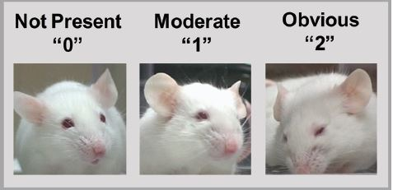
From Matsumiya et al, 2012, Using the Mouse Grimace Scale to Re-evaluate the Efficacy of Postoperative Analgesics in Laboratory Mice, JAALAS, Vol 51, No 1, January 2012, pp 42 - 49

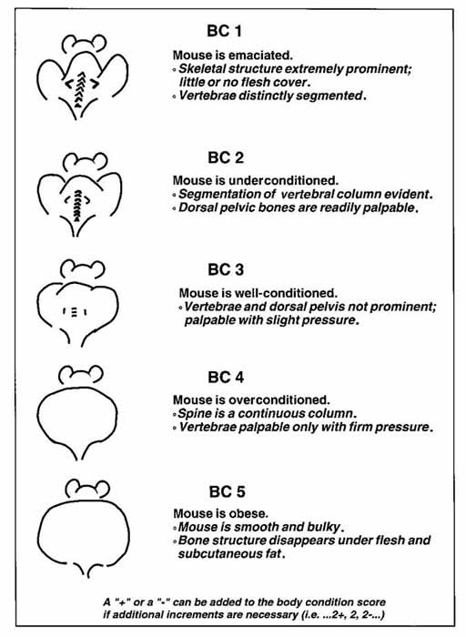

From Ullman-Culleré M H and Foltz C J, 1999, Laboratory Animal Science, Vol 49, No 3, June 1999

