FOCUS AREA | COVER LETTER
Activity | Deconstruct the cover letter
Duration | 45 minutes
Learning outcomes | Topic Coordinator to map to learning outcomes
Resources needed | - Sample cover letter  - Student worksheet  - Cover letter template (Career Hub)  - Cover letter checklist (Career Hub)  - Facilitator prompt sheets (PART B) and (PART C)
Associated toolkit task | 300-500 word cover letter

Activity description
Students will learn about the format of the one-page cover letter and how to structure the content. They will then take a recruiter’s perspective by comparing two candidates’ cover letters and identifying what works and what doesn’t in a cover letter.

PART A Format and structure [5 minutes]
Format | Steps | Prompts | Resources
Facilitator-led discussion | - Show the sample cover letter.  - Ask students largely ignore the content and focus on the structure and format – the number of paragraphs, date line, font size and consistency, placement of date and address etc. | - Who has written a cover letter before?  - Did their cover letter look like this? | Sample cover letter
 | - Briefly run through the traditional structural elements of the cover letter marked up on the sample. | For those who wrote a cover letter:  - Did they include a paragraph that talks about the organisation?  - What did they find challenging?

PART B Content – cover letter comparison [25 minutes]
Format | Steps | Prompts | Resources
Small group  exercise | - Students will take the role of a panel of recruiters reviewing the two candidates’ cover letters provided in Student worksheet (PART B) using the cover letter template and cover letter checklist. |  | Student worksheet (PART B)  Cover letter template (Career Hub)  Cover letter checklist (Career Hub)
 | - In student worksheet (PART B), they will make notes, paragraph by paragraph, about what they like and don’t like about each candidate and recommend a candidate to go through to the interview stage.
Facilitator-led discussion | - Ask students to report on their comparison of the two candidates’ cover letters. Which candidate did they choose? | Use our facilitator prompt sheet (Part B) and key messages to guide students in their dissection of the responses and for any questions. | Facilitator prompt sheet (Part B)  Key messages

PART C Making improvements [15 minutes]
Format | Steps | Prompts | Resources
Facilitator-led discussion | - Having chosen the preferred candidate (Candidate 1), invite students to look at the unsuccessful candidate (Candidate 2).  - Encourage students to identify – and then discuss – the three major improvements Candidate 2 could make. | 3 major improvements:  - Avoid spelling errors and generic phrases.  - Properly research the organisation and show this in the letter.  - Prioritise degree-related experience and make the tone a little more formal and professional, while keeping the impression of a cheerful and well-rounded individual. | Student worksheet (PART B) – Candidate 2’s letter
 | - Encourage the group to come up with alternative phrasing to three sections of Candidate 2’s letter. | Refer to our facilitator prompt sheet (PART C) for alternative phrasing providing additional evidence that enhances the candidate’s value. | Facilitator prompt sheet (PART C)

Key messages to convey to students
Facilitator: Ensure that you have reinforced these key messages during the activity or reinforce them at the end.
- The cover letter structure and format has not changed much over time – use the supplied cover letter template and checklist and it is difficult to go wrong.
- All cover letters should be customised and tailored to the job advertisement and organisation, specifically addressing the skills, knowledge and experience required for the role.
- If you have a specific connection with the organisation – e.g. a placement – introduce this earlier in your letter.
- Aim to integrate your information rather than trying to cover each aspect of your experience sequentially: e.g. ‘Through X, Y and Z, I have achieved A, B and C, which will enable me to E, F and G.’
- Ensure you understand the instructions for each application – requirements can vary enormously across different employers.
- Where feasible, try to find the name of the contact person
  - If you don’t have a name: Dear Human Resources', 'Dear ABC Company Recruiter', 'Dear Personnel Manager', 'Dear Hiring Manager' or 'To Whom It May Concern'
  - If you have a name but are unsure as to the pronoun they use, use a greeting like 'Dear Pat Smith.

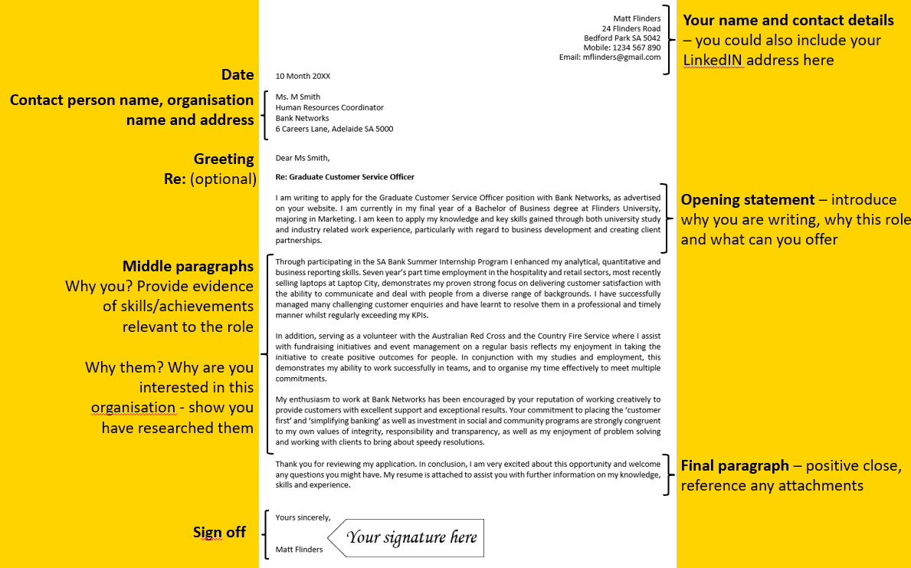
PART A Format and structure – sample cover letter

Facilitator ‘prompt sheet’
PART B Content – cover letter comparison
Paragraph 1
Candidate 1 | Candidate 2
- We learn where they saw the job advert, what they are applying for and what their Business degree major is.  - The final sentence is strong and quickly links what they want to contribute to the organisation, and introduces the fact quickly that they have sector experience. | - They haven’t indicated the role they are applying for – just the Graduate Position – there could be more than one! The second sentence is very self -focused – and anyone could say they are ideal for role!  - Needs to check spelling; From not form, and commendation, not condemnation  - They mention they are from regional SA – they could go further and link that to demonstrated qualities such as adaptability, motivation – or even to role – e.g. potentially working with rural banking clients.  - Avoid passive and wordy phrasing such as ‘I was required to…’  - Formalise language: University, not uni  - Improved is a weaker descriptor – alternatives include enhanced, developed, furthered, deepened etc.  - On the plus side they provide numerics in the form of the GPA, emphasise project skills and note individual and team skills, problem solving and business analytical skills.

Paragraph 2
Candidate 1 | Candidate 2
- Effectively unpacks the internship and skills gained – i.e. the benefits to the employer.  - Also highlights number of years of employment and relates their employment in a way relevant to the reader. | - On the plus side they have focused on their interest in the role, and mention evidence about their industry placement and employment – however this could have been presented much more effectively and with helpful specifics.  - The problems here are we don’t know where the candidate did the placement and we need specifics about how it is relevant to the role.  - Again, they need to formalise the language – ‘vast’ is not appropriate. Avoid passive and wordy phrasing such as ‘I had to’.  - The latter part of the paragraph has become bogged down with details that could go in the resume- this experience is valuable but needs to be related in a way that shows the transferrable skills relevant to the target role (rather than a retail role).

Paragraph 3
Candidate 1 | Candidate 2
- In one sentence we learn about 2 volunteer roles Candidate One is performing and can see this candidate’s values actively expressed (making positive outcomes for people) and connected to the role. These roles are used as evidence for the skills that are mentioned in this paragraph. | - They have aimed for a positive tone, and several positive qualities and skills are mentioned here, but little evidence is provided.  - It is good to see the mention of community sports involvement but again, not enough specific information is given about ‘helping out’ means in terms of volunteer contribution.  - Formalise the phrasing e.g. ‘a lot of’.  - Notice Candidate 2 is starting many sentences with ‘I’ – compare this to the more flowing style of Candidate One.

Paragraph 4
Candidate 1 | Candidate 2
- Candidate One has clearly researched the organisation and referred to key values, then shows their alignment to these values, well supported by the evidence provided in the second and third paragraphs. | - This is self focused – and about the benefits to Candidate Two’s career, not what they can offer and their interest in the organisation.  - Also, this is generic.

Paragraph 5
Candidate 1 | Candidate 2
- A good and professional close, referring to the attached resume.  - Correctly signs off with yours sincerely as they have addressed the letter to Dear Ms Smith | - Nice to see the thank you for considering their application. The tone of the last sentence could come across as ‘pushy’ however.  - Correctly signs off with Yours faithfully as the letter isn’t addressed to a named person.

Facilitator prompt sheet
PART C Making improvements ̶ alternative phrasing
Candidate 2’s letter | Suggested improvements
I have achieved an overall Grade Point Average of 5.4 (on a 7 point scale) | Achieving a GPA of X/7 reflects my X, Z and Y (link to the qualities sought).
I was required to do a number of individual and team projects at uni and this helped me improve my problem-solving capabilities and business analytical skills. My project work has received strong condemnation from my lecturers. | I completed several successful individual and team projects at university which consolidated my problem-solving capabilities and business analytical skills. My project work has received strong commendations from my lecturers and this was particularly valuable throughout my placement with Company Name which involved (unpack this experience in relation to the target role....).
I have a vast amount of customer service experience through my work with the Good Guys, showing my great people skills. I had to prepare rosters, arrange shelf space, help customers and provide back up to the cashiers and storeroom staff. | Through 3 years' employment with the Good Guys, where I took on responsibilities across multiple departments, I can further demonstrate my adaptability, ability to quickly learn new tasks on the job, develop rapport with team members and handle higher level duties.’

PART B Compare two cover letters

Instructions
In this activity you will work in small groups and take on the role of a recruitment panel.
- Review Candidate 1 and Candidate 2’s cover letters.
- Now, in the paragraph by paragraph comparison worksheet compare each of the candidates’ letters, making notes about what you like and don’t like about each candidates’ letter.
- Decide which candidate you will refer to the next stage of the recruitment process, the interview.

Candidate 1’s cover letter

Dear Ms Smith,
Re: Graduate Customer Service Officer
I am writing to apply for the Graduate Customer Service Officer position with Bank Networks, as advertised on your website. I am currently in my final year of a Bachelor of Business degree at Flinders University, majoring in Marketing. I am keen to apply my knowledge and key skills gained through both university study and industry related work experience, particularly with regard to business development and creating client partnerships.
Through participating in the SA Bank Summer Internship Program I enhanced my analytical and business reporting skills. Seven year’s part time employment in the hospitality and retail sectors, most recently selling laptops at Laptop City, demonstrates my proven strong focus on delivering customer satisfaction with the ability to communicate and deal with people from a diverse range of backgrounds. I have successfully managed many challenging customer enquiries and have learnt to resolve them in a professional and timely manner whilst regularly exceeding my KPI’s.
In addition, serving as a volunteer with the Australian Red Cross and the Country Fire Service (CFS) where I assist with fundraising initiatives and event management on a regular basis reflects my enjoyment in taking the initiative to create positive outcomes for people. In conjunction with my studies and employment, this demonstrates my ability to work successfully in teams, and to organise my time effectively to meet multiple commitments.
My enthusiasm to work at Bank Networks has been encouraged by your reputation of working creatively to provide customers with excellent support and exceptional results. Your commitment to placing the ‘customer first’ and ‘simplifying banking’ as well as investment in social and community programs are strongly congruent to my own values of integrity, responsibility and transparency, as well as my enjoyment of problem solving and working with clients to bring about speedy resolutions.
Thank you for reviewing my application. In conclusion, I am very excited about this opportunity and welcome any questions you might have. My resume is attached to assist you with further information on my knowledge, skills and experience.
Yours sincerely,
Name

Candidate 2’s cover letter
To Whom It May concern
I wish to apply for the Graduate position. Seeking my first graduate role I am keen to kickstart my career, and I believe I am the ideal candidate for this position. Originally form regional SA, I have a Bachelor of Commerce from Flinders University I have achieved an overall Grade Point Average of 5.4 (on a 7 point scale). I was required to do a number of individual and team projects at uni and this helped me improve my problem-solving capabilities and business analytical skills. My project work has received strong condemnation from my lecturers.
I wish to work for a bank as I particularly enjoy working on projects that provide a clear business benefit and am keen to have a high level of client contact. During my industry placement I produced a report on Business Quality Management, which has given me experience highly relevant to this role. I have a vast amount of customer service experience through my work with the Good Guys, showing my great people skills. I had to prepare rosters, arrange shelf space, help customers and provide back up to the cashiers and storeroom staff.
I am a cheerful worker with a great work ethic, energetic personality, a desire to achieve, good team work skills and a lot of project experience. In my free time I like to help out with my local tennis club.
I am confident this opportunity will give me the growth and challenges I am looking for in my career.
Thank you for considering my application. I have attached my resume and academic transcript. I would appreciate an interview and am available at short notice and for an immediate start.
Yours faithfully
Name

Paragraph by paragraph comparison

Paragraph 1 Introduce why you are writing, why this role and what can you offer
Candidate 1 | Candidate 2
I am writing to apply for the Graduate Customer Service Officer position with Bank Networks, as advertised on your website. I am currently in my final year of a Bachelor of Business degree at Flinders University, majoring in Marketing. I am keen to apply my knowledge and key skills gained through both university study and industry related work experience, particularly with regard to business development and creating client partnerships. | I wish to apply for the Graduate position. Seeking my first graduate role I am keen to kickstart my career, and I believe I am the ideal candidate for this position. Originally form regional SA, I have a Bachelor of Commerce from Flinders University I have achieved an overall Grade Point Average of 5.4 (on a 7 point scale). I was required to do a number of individual and team projects at uni and this helped me improve my problem-solving capabilities and business analytical skills. My project work has received strong condemnation from my lecturers.
Comments: | Comments:

Paragraph 2 Outline your relevant skills, qualifications, and experience appropriate to the position. Make sure you read the advertisement/position description thoroughly (could be 1-2 paragraphs)
Candidate 1 | Candidate 2
Through participating in the SA Bank Summer Internship Program I enhanced my analytical and business reporting skills. Seven year’s part time employment in the hospitality and retail sectors, most recently selling laptops at Laptop City, demonstrates my proven strong focus on delivering customer satisfaction with the ability to communicate and deal with people from a diverse range of backgrounds. I have successfully managed many challenging customer enquiries and have learnt to resolve them in a professional and timely manner whilst regularly exceeding my KPI’s. | I wish to work for a bank as I particularly enjoy working on projects that provide a clear business benefit and am keen to have a high level of client contact. During my industry placement I produced a report on Business Quality Management, which has given me experience highly relevant to this role. I have a vast amount of customer service experience through my work with the Good Guys, showing my great people skills. I had to prepare rosters, arrange shelf space, help customers and provide back up to the cashiers and storeroom staff.
Comments: | Comments:

Paragraph 3 Outline your relevant skills, qualifications, and experience appropriate to the position. Make sure you read the advertisement/position description thoroughly (could be 1-2 paragraphs)
Candidate 1 | Candidate 2
In addition, serving as a volunteer with the Australian Red Cross and the Country Fire Service (CFS) where I assist with fundraising initiatives and event management on a regular basis reflects my enjoyment in taking the initiative to create positive outcomes for people. In conjunction with my studies and employment, this demonstrates my ability to work successfully in teams, and to organise my time effectively to meet multiple commitments. | I am a cheerful worker with a great work ethic, energetic personality, a desire to achieve, good team work skills and a lot of project experience. In my free time I like to help out with my local tennis club.
Comments: | Comments:
Paragraph 4 Build the connection. Why are you interested in this organisation? Show the employer that you have researched the company/workplace by highlighting some information about it. Avoid being generic.
Candidate 1 | Candidate 2
My enthusiasm to work at Bank Networks has been encouraged by your reputation of working creatively to provide customers with excellent support and exceptional results. Your commitment to placing the ‘customer first’ and ‘simplifying banking’ as well as investment in social and community programs are strongly congruent to my own values of integrity, responsibility and transparency, as well as my enjoyment of problem solving and working with clients to bring about speedy resolutions. | I am confident this opportunity will give me the growth and challenges I am looking for in my career.
Comments: | Comments:
Paragraph 5 Positive close reinforcing your interest in the role. Reference any attachments (if appropriate).
Candidate 1 | Candidate 2
Thank you for reviewing my application. In conclusion, I am very excited about this opportunity and welcome any questions you might have. My resume is attached to assist you with further information on my knowledge, skills and experience.  Yours sincerely,  Name | Thank you for considering my application. I have attached my resume and academic transcript. I would appreciate an interview and am available at short notice and for an immediate start.  Yours faithfully  Name
Comments: | Comments:

