FOCUS AREA | EMPLOYABILITY AND TECHNICAL SKILLS
Activity | Audit your skills
Duration | 40 minutes
Learning outcomes | Topic Coordinator to map to learning outcomes
Resources needed | - Student worksheet  - 14 common skills assessed by graduate employers in 2021  - Employability and Innovation Skills Checklist (Career Hub) and Personal Skills Checklist
Associated toolkit task | 1000-1500 word reflective essay

Description

Students will be led through a series of exercises to explore their skills development. They will consider the variety of contexts in which skills are developed – i.e. through education, employment and extra-curricular activities – and create their own ‘skills audit’ that they can carry through their studies.

PART A Identify the skills on display in each scenario [10 minutes]
Format | Steps | Prompts | Resources
Facilitator-led discussion | - Broadly introduce employability and technical skills. | Employability skills:  - are the foundational skills necessary to manage our careers and transition between roles and careers  - are increasingly sought after by employers in a rapidly changing labour market  - may also be referred to as ‘soft’, ‘enterprise’ or ‘transferable’ skills  - e.g. teamwork, digital literacy, organisational skills etc.  Technical skills:  - the specialist knowledge and expertise needed to perform in particular occupations/sectors  - may also be referred to as ‘hard’ skills. | Facilitator may like to provide technical skills examples relevant to the course
 | - Ask students to read the two written scenarios provided in student worksheet (PART A). | - These scenarios show how a variety of skills attractive to employers can be developed and demonstrated through our study, work and life experiences. | Student worksheet (PART A)
 | - Lead a discussion encouraging students to identify the employability skills identified in the two scenarios. | Example 1  - Organisation, prioritisation, interpersonal, initiative, problem-solving, working under pressure, customer service, negotiation, creativity, commercial awareness  Example 2  - Teamwork, organisation, verbal communication, report writing, research, analytical, innovation, cultural intelligence, emotional intelligence, leadership, meeting facilitation, social media, project management, organisational skills, time management, problem solving, presentation skills, consultation etc.

PART B Identify the skills on display from a recent course task [10 minutes]
Format | Steps | Prompts | Resources
Facilitator-led discussion | - Refer students to student worksheet (PART B) and [INSERT RECENT COURSE ASSIGNMENT OR ACTIVITY].  - Lead a discussion asking students to identify (and note) the skills they used to complete the task. | - What technical/discipline skills did you use?  - What employability skills did you use?  - Are you surprised by the range of skills demonstrated through this assignment/activity?  - How might these skills be useful in your future career? | Student worksheet (PART B)

PART C Rate your skills [10 minutes]
Format | Steps | Prompts | Resources
Facilitator-led | - Provide students with the 14 common skills assessed by graduate employers in 2021. | - These skills come from an annual survey of Australia’s top graduate employers which asks the common skills they look for in their graduate recruitment processes. | 14 common skills assessed by graduate employers in 2021
Individual exercise | - Ask students to rate their level of skill using student worksheet (PART C) | - What skills do people acknowledge you for?  - Be as objective as you can in rating your skill level.  - If you tend to be critical about your level of skill, you can ask a friend to help give a balanced view. | Student worksheet (PART C)
 | - Ask students to make brief notes in student worksheet (PART C) describing 3x situations where they have demonstrated their top 3x skills. | - The situation may come from any context – education, sector-related experience, employment and extra-curricular activities that demonstrates evidence of your skill development.  - Try to think of specific situations which could be expanded later into scenarios like those provided in PART A.  - Being able to provide recruiters with specific examples of where you have demonstrated a skill is essential for preparing written applications and interviews.
Facilitator-led discussion | - Invite students to share their top skill and the situation in which they demonstrated it. | - Which were your top skills in this activity?  - In what situations did you demonstrate them?  - What skills would you like to be acknowledged for in the future?

PART D Map your skills [10 minutes]
Format | Steps | Prompts | Resources
Facilitator-led | - Provide students with the Personal Skills Checklist and Employability and Innovation Skills Checklist. | - You may like to use the checklist to prompt your ideas for the next activity. | Personal Skills Checklist  and Employability and Innovation Skills
Individual exercise | - Using student worksheet (PART D) ask students to record the skills they have developed in each of the four work, life and study contexts. |  | Student worksheet (PART D)
Facilitator-led discussion | - Lead a discussion identifying what students found. | - What situations have accounted for your greatest list of skills to date?  - Which skills would you most like to use in future? Why?  - Have you identified any skills gaps? What skill development might you do to address them?

Tips for teaching staff
This activity would be an ideal precursor to the selection criteria activity: Introducing STAR and creating your brag file (if students haven’t previously completed it).

PART A Identify the skills on display in each scenario
You will often be asked to provide examples of times when you have demonstrated a particular skill in applications and interviews. Knowing how to speak about your skills and recognising their value to employers is an important skill in itself. Here are two excellent scenarios rich in a variety of skills. Examples like this can be tweaked and repurposed in interviews and applications to show how you have developed and applied a particular skill or criterion.
In your group discuss and note down the skills that have been demonstrated in each example.
Example 1
Working as a waitress in the Fine Wine Bar at the Convention Centre of Australia, I needed to take customers’ orders and serve food, coffee, and drinks. Sometimes the team was understaffed which resulted in delayed service. A family had come into the restaurant and ordered lunch to dine in, but after waiting some time for their orders to arrive they notified me that their son would have to leave soon. I offered sincere apologies. After checking with the chef about the delay, I relayed to the customers that the food would still take some time to be ready and offered free coffees to make up for the poor service. I offered take away coffee cups as I knew the son had to leave. They were visibly pleased by this suggestion and took the offer. After eating the meals, they commented on how delightful it was and how they would be returning another time when they were not so rushed. This decision established a good rapport with the customers and made them feel heard. Despite their initial frustration, I was able to change their views with a simple offer that would not dramatically affect costing within the business.

Example 2
During March 2021, I was involved in the Future Leaders Competition, as a member of a team acting as management consultants to the multinational consulting firm XYZ Networks. Our task was to prepare a business report and presentation of our recommendations on an issue proposed by the organisation. The team of 8 was a highly diverse mix of nationalities, generations and disciplines and we had a tight time frame to get to know each other and cohesively function to achieve our outcome.
As well as being team leader, I was involved in research and analysis of the issue, which included liaising with and benchmarking other consulting services’ and other recognised ‘employers of choice’; the collation of the 30-page business report; and the preparation and delivery of the recommendations we presented. We met regularly, constructed project timelines, used a Trello Board for communications, and created small working parties (such as research, IT) to resolve task specific issues. These working parties then converged to discuss broader project issues. As leader I ensured conflicts were resolved quickly by the appropriate parties and that they were conducted with open communication and mutual respect. The result was that we could consider diverse perspectives, while staying on task and keeping to time-frames.
Our presentation was so highly regarded by our organisation that it led to our team representing SA in the National Finals.

PART B Identify the skills on display from a recent course task

During your studies you are developing both technical and employability skills. Think about [INSERT RECENT COURSE ASSIGNMENT OR ACTIVITY]. What technical and employability skills did you use to complete the task?

PART C Rate your skills
- Working individually consider the handout: the 14 common skills assessed by graduate employers in 2021
(AAGE 2020).
- Tick which skills you have developed.
- Rate your level of skill from 1-4 according to the rating key. Be as objective as you can. If you tend to be critical about your level of skill, enlist a friend to help give a balanced view.
- Identify your top three skills and note a situation where you have demonstrated it.
  - The situation may come from any context – education, sector-related experience, employment and extra-curricular activities. This will provide evidence of your skills.
  - Try to think of specific situations which could be expanded (if needed) into scenarios like those provided in Part A. This is an essential skill in demonstrating your skills through written applications and interviews.
Skill |  | Rating | Situation  e.g. customer service role, uni team project, juggling work, study and other commitments
Communication skills
Teamwork
Interpersonal skills
Resilience
*Understanding of our organisation
Self-management
Initiative and enterprise
Emotional intelligence
Planning and organising
Leadership
Commercial awareness
Technology
Relevant work experience
University grades

Rating key | 1 = interested, but not skilled | 2 = partly skilled | 3 = skilled | 4 = highly skilled
*This may not be immediately relevant to this activity but employers want their potential new recruits to demonstrate they have researched the organisation. This is commonly overlooked in applications and interviews and a frequent grievance of employers. Don’t miss this opportunity to draw the connection between ‘you’ and ‘them’.

PART D Map your skills

In the table below write down the skills you have developed in each of the four contexts – education, sector related experience/employment, other employment and extra-curricular settings. You may like to consult the Personal Skills Checklist and Employability and Innovation Skills to prompt your ideas. The same skill may appear in each column, while others may only appear in one.
MY SKILLS AUDIT
Education  e.g. current and former study, course projects | Sector-related experience/employment e.g. volunteering, placement, internships, vacation work | Other employment  e.g. casual, professional – other sector | Extra-curricular  e.g. community work, sport, music, interests
Examples  - Technical skills (be specific in your list)  - Project management  - Problem-solving  - Research | Consider  - the skills that are specific to your sector and the skills you are using to apply your course knowledge. | Examples  - Customer service  - Conflict management  - Reliability | Examples  - Organisational  - Teamwork  - Leadership
Remember:
- Employers value well-rounded graduates with both technical and employability skills.
- Showcasing skills developed across a diversity of contexts will help you stand out.
- Keep your ‘skills audit’ up to date as you move through your studies.
- This might feel like a list of generic skills now but this audit will help you later when you need to provide detailed evidence for how and where you have developed key skills in written applications and interviews – like those shown in PART A.

14 common skills assessed by graduate employers

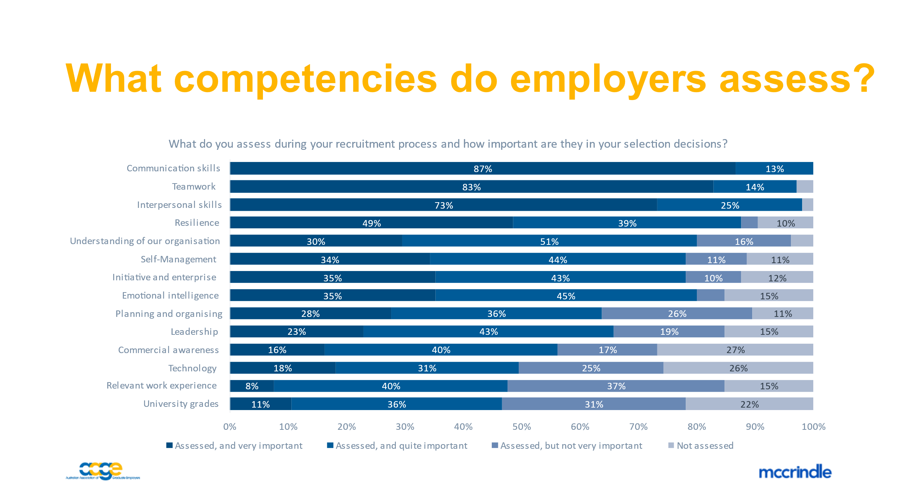
Source: AAGE (2020). 2021 AAGE Employer Survey, Australian Association of Graduate Employers Ltd., Camberwell, Victoria. (Accompanying slide deck.)

