Safe Work Procedure
Task/Activity/Plant/Equipment:
Disposal of hazardous chemical waste
Location:  College of Science & Engineering |  | RA Number:
SWP Number: | SWP prepared by:  Tanya Rodaro | Date:  6/03/19 | Review Date:  6/03/24

What warnings and/or protective measures must be taken when using this equipment?

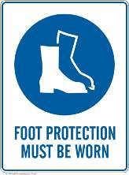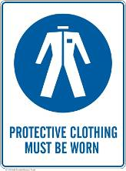
HAZARDS

Refer to Risk Assessment
Hazardous chemicals – exposure risk
Hazardous chemicals – transport in lift
Hazardous chemicals - accidental spill or mixing

PRE-OPERATIONAL SAFETY CHECKS DO NOT USE DEFECTIVE OR FAULTY EQUIPMENT
1 | Ensure waste is stored in appropriate containers according to Chemwatch, in good condition and labelled correctly, with either a manufacturers label or Chemwatch label. Affix a waste label if required (available at the store or printable labels on the College FAQ page)
2 | Create a manifest of the waste using the standard form found on the College FAQ page. Enter as much data as possible using the Safety Data Sheet for reference. There is no need to fill out the EPA waste code. The DG class and Packing Group is available on Chemwatch SDS Section 14 Transport Information.
3 | Email manifest of hazardous chemicals to cse.whs@flinders.edu.au
4 | Ensure approval to transfer waste has been received before proceeding
5 | Organise a time with the Work Health Safety Officer or a member of your laboratory group who is experienced with hazardous waste disposal to assist you with the transportation.
6 | Consider the use of PPE relevant to the waste that will be transported. Use the Safety Data Sheet to ensure correct PPE is adhered to.

OPERATIONAL SAFETY
1 | Collect the key to Carpark 7 bulk solvent store from the College store (2 people must be in attendance or key will not be handed out).
2 | If only transporting a small quantity of waste it may be carried in a secondary container. A trolley should be used for mixed waste or larger quantities. A bunded trolley should be used for transporting of hazardous chemicals and can be borrowed from the College store. Load trolley with hazardous chemicals. Ensure careful attention to segregation of chemicals where necessary using figure 2 for reference. It may be necessary to use plastic tubs also available at the College Store to segregate chemicals or make repeated trips.
3 | If a lift is required to access the solvent store, the lift barrier must be engaged on the inside of the lift doors as per figure 1 below and personnel must not travel in the lift with the waste.
4 | Waste must be transported to the bulk solvent store. Waste should be left on the right hand side shelving ensuring appropriate segregation and labelling is correct.
5 | Ensure the door to the solvent store is closed and locked.

POST-OPERATIONAL
1 | Return the key to College Store.
2 | If used, return the bunded trolley to the College Store.

MAINTENANCE
1 | Be aware of the location of your nearest spill kits. Each laboratory should have a spill kit. A larger spill kit is available centrally in most buildings as well.

REFERENCES (EG. MANUFACTURER’S MANUALS / AUSTRALIAN STANDARDS)
1 | Use in conjunction with the CSE Procedure for Faculty Solvent Store found on the College FAQ page

Authorised by Supervisor:
 | Name | Signature | Date

Declaration
I hereby state that I have read and understood the Safe Work Procedure on the previous page, and will abide by the operating requirements.
Name | Signature | Date

FIGURE 1: LIFT BARRIER IN ENGAGED POSITION
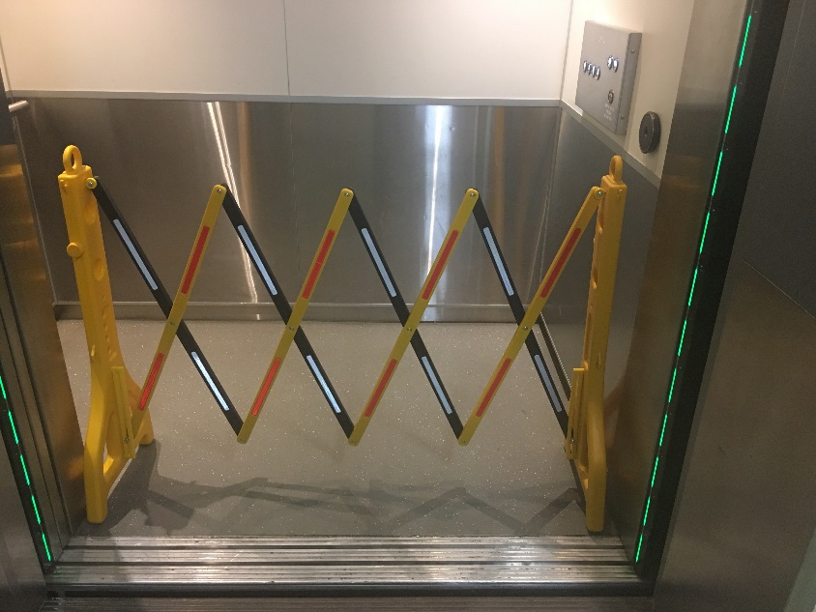

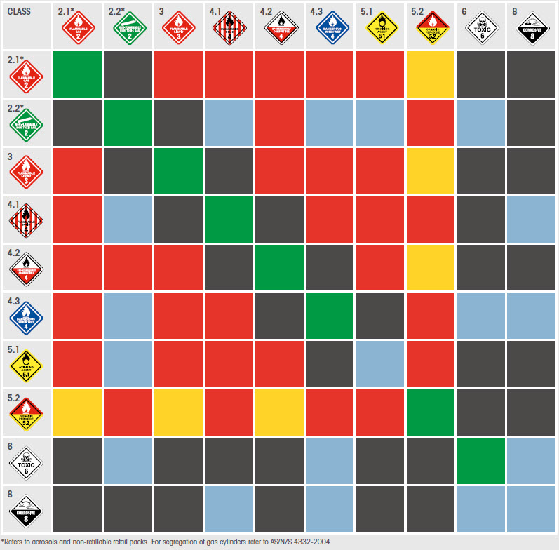
FIGURE 2: DANGEROUS GOODS COMPATIBILITY & GHS COMPARISON CHART

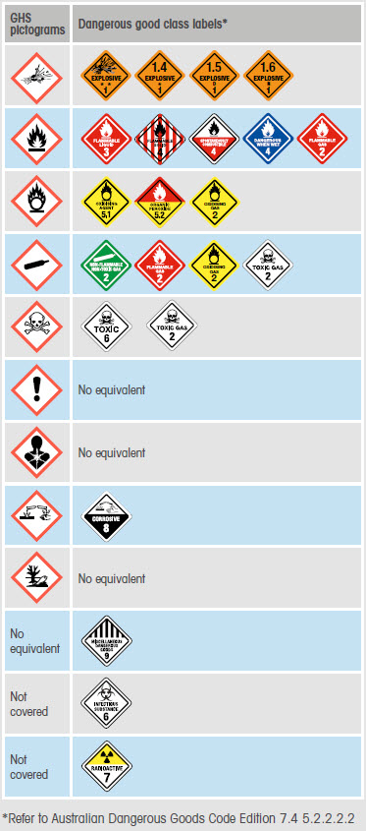

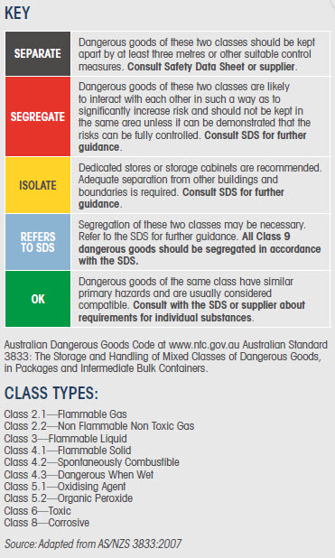

Source: Adapted from http://www.comcare.gov.au/__data/assets/pdf_file/0010/155089/03895_RO_GHS_ADG_quick_guide_v99x210_v28.pdf

