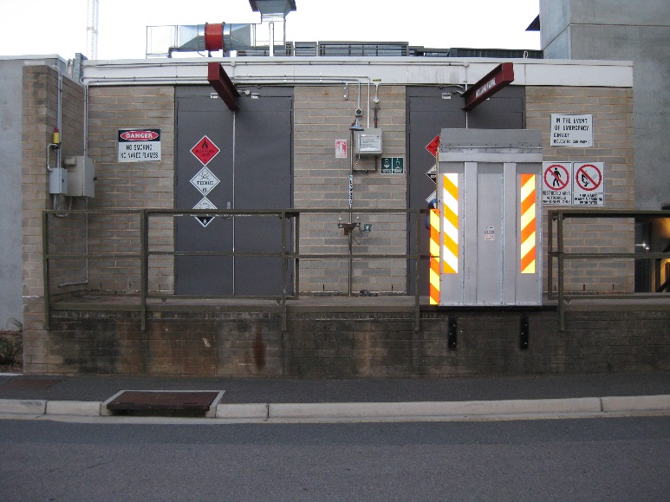

Procedure for Bulk Solvent Store, Carpark 7
The aim of this document is to provide clear and concise stepwise instructions for users of the bulk solvent store.

General Introduction
The Bulk Solvent Store (pictured above) is located in Carpark 7 and is used to
- Hold the College Store of bulk flammable solvents (20 L or 205 L drums). Solvents stored here may include ethanol, acetone, hexane, ethyl acetate and toluene.

- Store chemical waste which is removed regularly by an Environmental Protection Agency (EPA) licenced waste contractor.

- Store for research and teaching groups of bulk flammable chemical substances.

The purpose of the bulk solvent store is to redirect the flammable load from the main buildings.

Solvent Store Key Access Procedure
This procedure is compulsory for all persons requiring access to the Bulk Solvent Store.

- Due to the remote location of the Bulk Solvent Store it is a requirement that two people must be in attendance at all times when utilising the facility.

- The key to the Bulk Solvent Store is held in the College Store.

- To access the Bulk Solvent Store both people must sign the “solvent store key and waste log” (located in the College Store) before the key will be released.

- At all times whilst in the Bulk Solvent Store, both persons must wear the appropriate personal protective equipment. This is based upon the activities being carried out at the time and the safety signage. Note: to help move loads a bunded trolley is available from the College Store.

- Upon exiting the facility please ensure that the lights are switched off and the door is securely locked.

- The key (and trolley) must be returned to the College Store immediately and the person returning it must sign out on the “solvent store key and waste log”.

Storage of Teaching and Research Group Chemical Substances
This procedure is compulsory for all persons depositing chemical substances within the bulk solvent store.

- The SDS for all research and teaching group materials stored within the bulk solvent store must be provided to the store personnel prior to the substance being stored.

- All substances must be labelled appropriately with manufacturers GHS format labels or labels generated by Chemwatch GHS template.

- The container must also clearly show the details of the research or teaching group, lab/room.

Solvent Store Chemical Waste Disposal Procedure
This procedure is compulsory for all persons depositing chemical waste in the Bulk Solvent Store for later removal by EPA licenced waste contractors. ALL waste must be appropriately labelled.

- All chemicals must be added to a Cleanaway Waste Manifest before transferring the chemicals into the waste area of the solvent store.

- Request an electronic copy of the form from the CSE stores and once completed return it via email to: cse.store@flinders.edu.au

- The key to the Bulk Solvent Store can be collected from the CSE Store

Mixed liquid wastes must be classified as either:
- Aqueous (display pH)
- Heavy metals
- Solvent waste

- Contact the College Store for empty containers and labels.
- Waste containers must be stored in their allocated area as shown in image below.
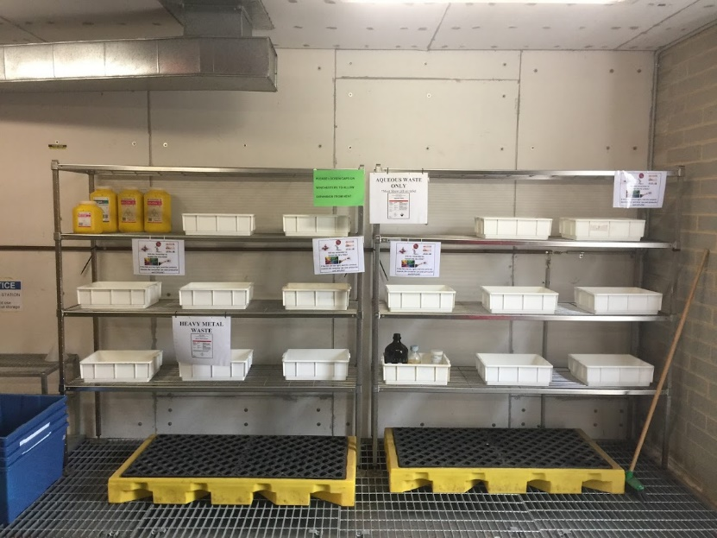

Other Chemicals
All other chemicals must display either their original commercial labelling or as a minimum:
- chemical name,
- dangerous good class/ GHS and CAS number,
- origin – i.e. where the chemical came from e.g. the Building and lab/room number.

If you require any further details on the above procedures, contact CSE Store staff via email or phone
cse.store@flinders.edu.au / ext. 13993 or 12167

