Setting up WorkRave

Step 1: In the bottom right-hand corner of the screen (by the time), click on the arrow pointing up (1) to reveal the icons. Right-click on the little ‘sheep’ icon (2) and click on Preferences (3).

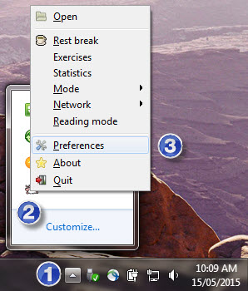

Step 2: The Preferences window will appear. Make sure the Micro-break tab is selected and ensure the Enable Timer is not ticked (see below).

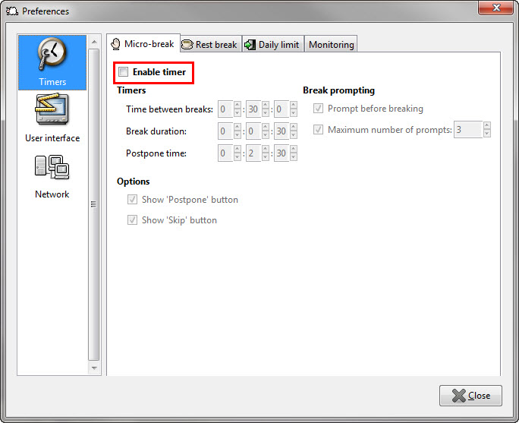

Step 3: On the Rest Break tab, ensure the Enable Timer is ticked (1). Also check that the time between breaks is 30 minutes (2). The Start rest break when screen is locked option can be left unticked or ticked as required (3). This means the rest break will start if the screen is locked and count towards you taking a break and reset the ‘Time between breaks’ reminder time.

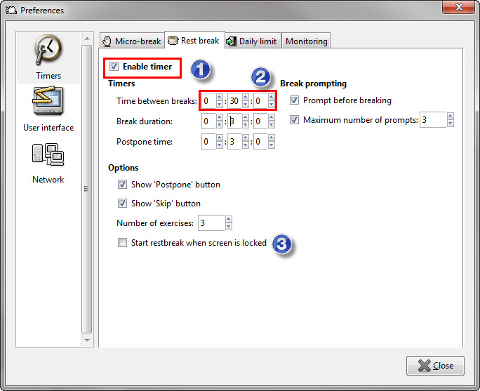

Step 4: On the Daily Limit tab, choose to either untick or tick Enable Timer. Normally this option can be left off, however you may wish to have a reminder about spending too much time at the computer in one day.

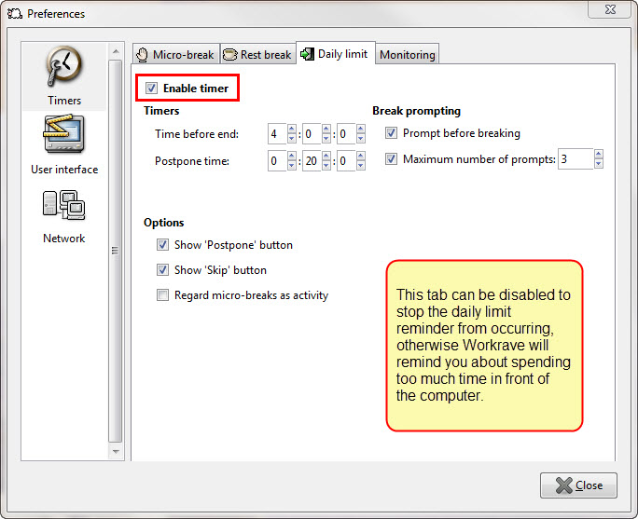

Step 5: Click on User Interface (see below on left side). Choose Language as English (1) and ensure both “Show system tray icon” (2) and “Start Workrave on Windows startup” (3) are ticked. Click Close (4) when done.

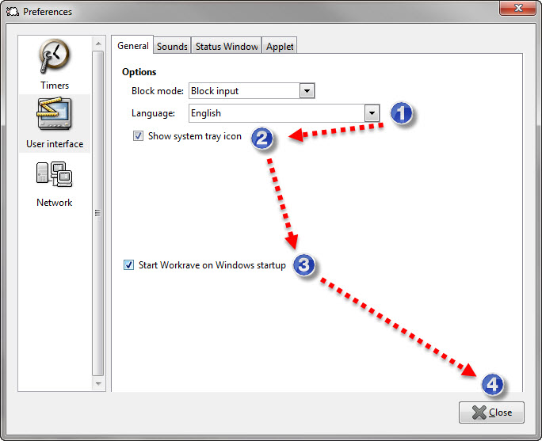

Workrave should now be configured to run when typing occurs throughout the day for longer than 30 minutes continuously.

